Parenting and mental health conference 2015

impact report

Vision
Reduce fear of parents and services. To mark World Mental Health Day 2015. The aim of the conference was to Celebrate World Mental Health Day and to bring parents and professionals together.
“We want to think about how we can make people feel safer being open with services and make services less frightened of us being open with them. We want to increase openness and honesty from both sides as we feel that if this is possible and we can trust each other and work together that will be best for all of us.” Debs Taylor speaking at the beginning of the conference.
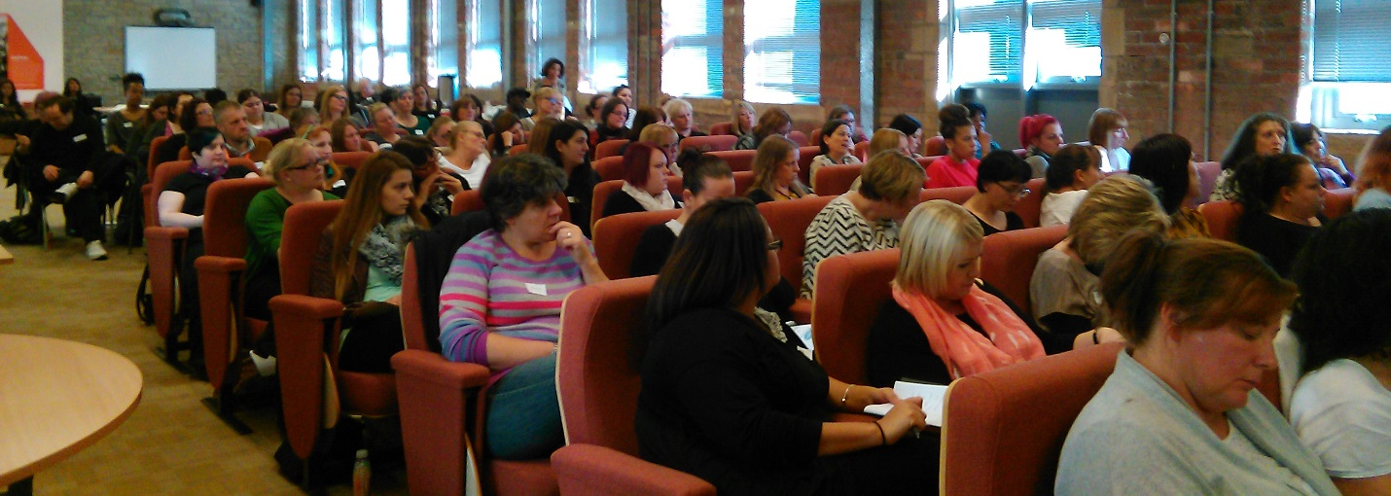
Delegates at start of conference (Above image)

Why?
“We decided that we would do this conference because several members of the forum had had experiences of services which made them think differently about the way services worked, but also how they would respond if they were to face those services again.
Sadly I (and a few others) have said we would not be as open and honest as we feel that this actually made our situation worse. Although we feel it's best to be open and honest about our lives and the illness that we live with, sadly not everyone took it as that and made us feel we had to jump through hoops to prove we were responsible and safe parents to our children. The focus was on us proving ourselves and assessing risk instead of on what support we or our family might need.
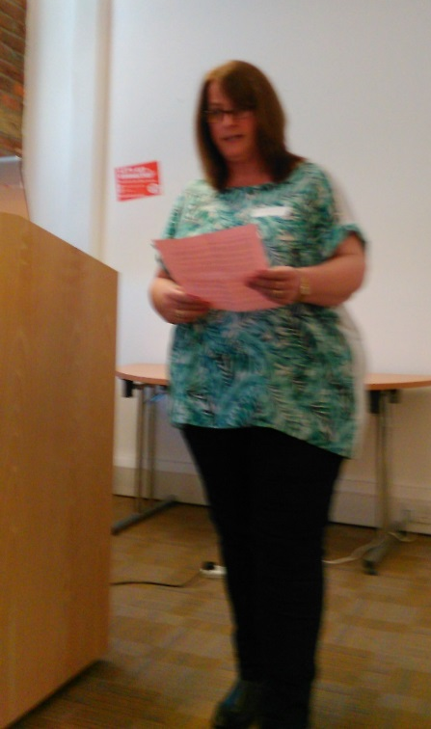 | “It is a shame that my experiences mean that I am likely to be less open and less likely to ask for support if I need it. Hopefully this conference can be a starting point in changing this, hopefully it will increase communication, trust and understanding between service users and providers.” Debs Taylor speaking at the beginning of the conference.  Debs Taylor Speaking (image on left)
We want to think about how we can make people feel safer being open with services and make services less frightened of us being open with them. We want to increase openness and honesty from both sides as we feel that if this is possible and we can trust each other and work together that will be best for all of us.” Debs Taylor speaking at the beginning of the conference.

Co-production
The idea for the conference came from parents with personal experience of mental health difficulties who attend Healthy Minds Forum. People with direct personal experience were also involved in developing and facilitating all aspects of the conference.
As an organization we believe it is important that people who experience mental health problems are seen as equal partners in designing and delivering services, that we provide opportunities to recognise and grow people’s capabilities and that this is done within an atmosphere of reciprocity and mutuality. This is reflected in all the work done by Healthy Minds and is in line with the principles that are embedded in the best co-production (Slay, J. & Stephens, L. (2013)
"Co-production means delivering public services in an equal and reciprocal relationship between professionals, people using services, their families and their neighbours" (New Economics Foundation)

Activities

Workshops
There was a variety of workshops available facilitated by people from the NCT, Sam Warner, Siobhan Beckwith and Healthy Minds staff. These workshops were all for parents with direct personal experience of mental health problems and the professionals that work in this area.
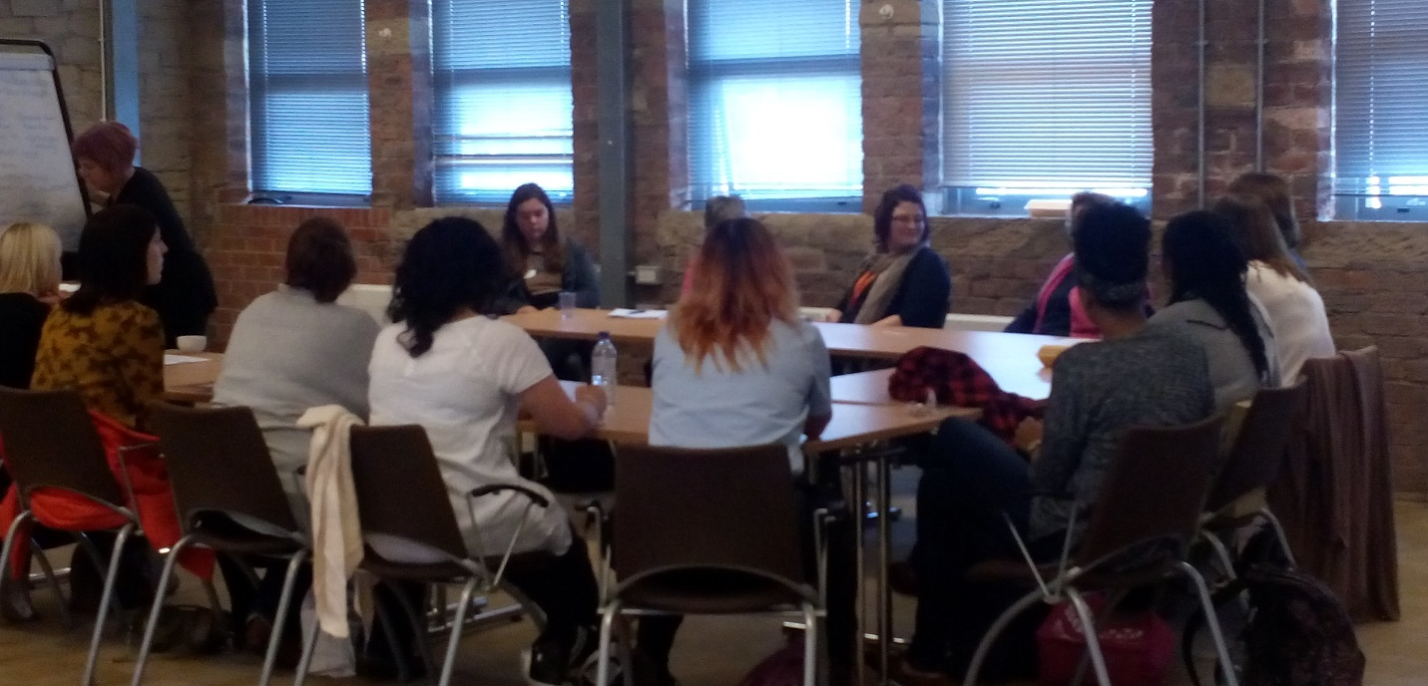
Delegates in workshop (above image), Picture from creative workshop (below image)
Workshops focused on:  - Making services accessible  - Bringing services and service users together to reduce fear  - Creative workshop to explore thoughts and  feelings  - Helping individuals with the fear of early parenting; including anxieties about medication  - Good enough parenting | 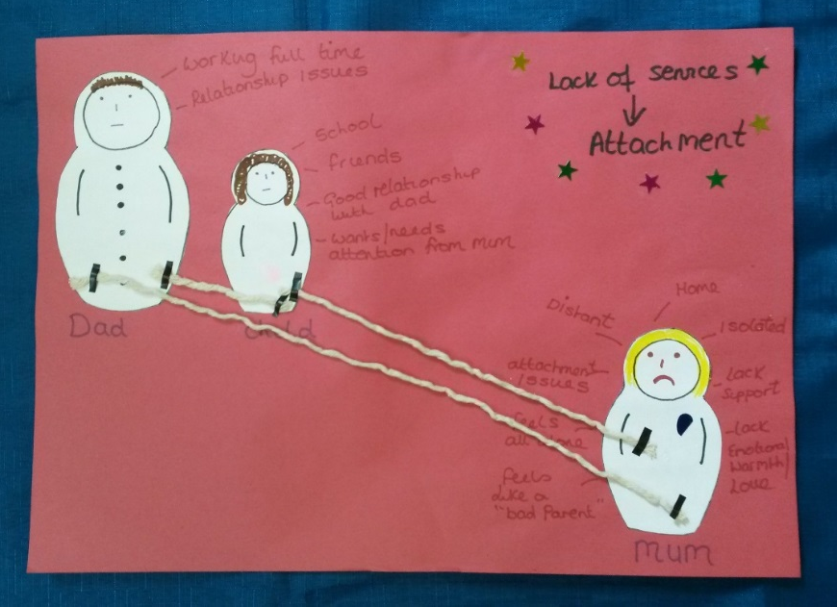
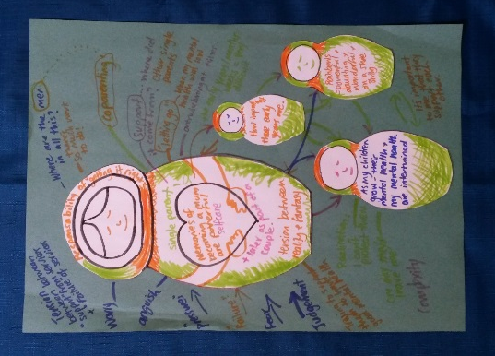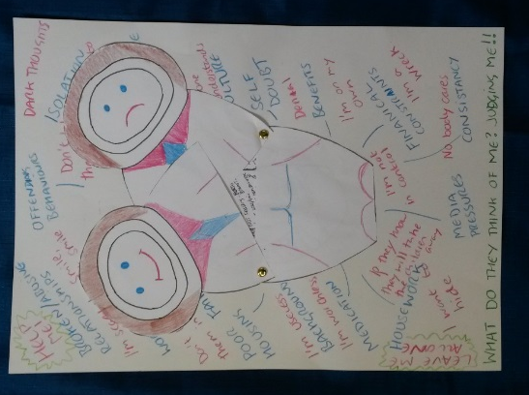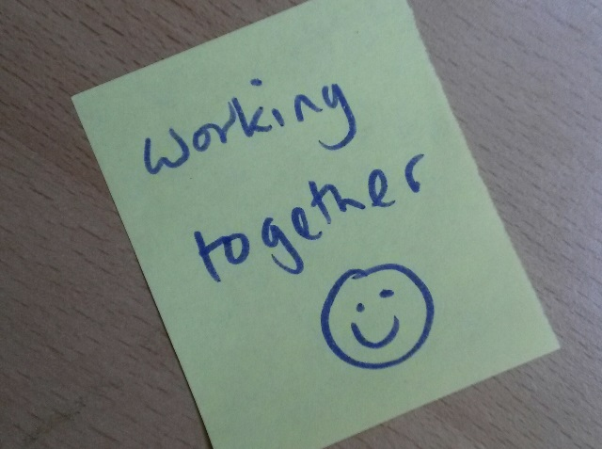

Speakers
Speakers included Clinical Psychologist Sam Warner, Katrina Jenkins from the Mental Health Foundation, Siobhan Beckwith from Women Centre Calderdale and Kirklees, Steve Lyons from Huddersfield University, parents with experience of using mental health services as well and Healthy Minds Trustee Karen Newbigging.

Speakers focused on:
- Parenting and mental health in context, the national picture
- Personal experinces of parents with mental health problems
- Identifying and reducing fear: different perspectives
- Cultural Accessibility
- Good enough services
- Co-creation approaches to wellbeing

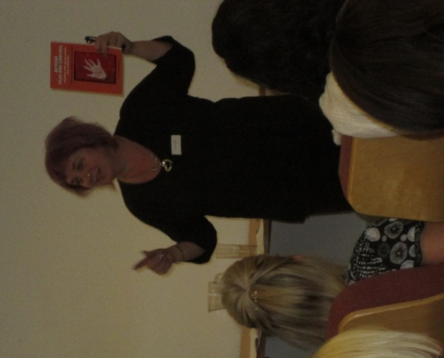

Sam Warner speaking (above left image) Karen Newbeggin speaking (above image)

The experiences of parents
“I got to know the community midwife who was a specialist Mental health midwife. She was really good at listening and communicating with me. She had had postnatal depression herself with one of her pregnancies. She was clear that just because I had experienced problems in the past, didn’t mean that I would necessarily suffer from postnatal depression this time. I built up a positive relationship with her and worked with her to create a birth plan for my needs.” Katie Siobhan

“When I met my health visitor after my baby was born she had only seen the hospital notes which didn’t give her an accurate picture of me or my family. However she sees me as a person and a mum and she only addressed stuff in relation to mental health if it is relevant and needs addressing, or when I bring it up. She also sees my family as a family and works with us as a family which I am thankful for and which works really well. “ Katie Siobhan

Film
We worked with some parents with experience of using services to create a film about their experiences. This was shown for the first time during the conference.
The film can be found on this link:
https://www.youtube.com/watch?v=h-s29npxL1A

Networking
The conference brought together people from different professions and services in Calderdale who work with parents experiencing difficulties with their mental health. It also brought professionals together with parents who use or who have used services. This was a rare opportunity for many involved as they said there are not many events like this in Calderdale.
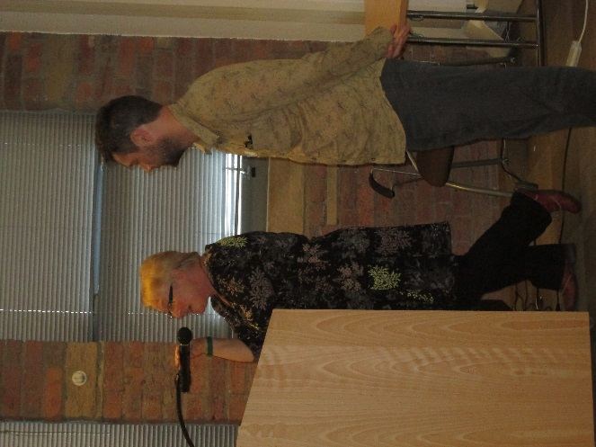
Delegates networking during conference (above left) Staff and Trustee (above right)

Action points

Information
- Create a single database with information about all relevant services, which can be accessed in different ways by professionals and the community/ people who use services. This should be managed by one person/ organisation and have ongoing funding.

- Increase signposting between services, in particular between health and social care and to vol. sector from G.P.s.

- Create more opportunities for peer support and strengthen existing peer support networks.

Best practice
- When planning and providing services, recognise parents’ fear of accessing services and help them recognise, celebrate and build on their strengths.

- Ensure that people who use services have a voice in the service/s they use. This may involve thinking creatively about ways to involve people or paying them for their input.

- Give parents as much choice and control over what support they access. This includes providing in depth information about available services.

- Create more networking and learning opportunities for organisations providing services.

- Create a platform for service-users voices to be heard by service providers, policy makers and commissioners across the borough.

Accessibility
- Increase access to independent interpreters and provide more services in people’s first language.

- Raise awareness of mental health problems and available support across all communities in Calderdale. This should include greater viability of services in the community.

- Use more of a variety of media to publicise services including community radio networks.

- Recruit staff who are more representative of the local population and communities and recognise and value the extra strengths they bring to services.

ACTION POINTS WERE PASSED ON TO EVERONE WHO ATTENDED AND RELEVANT ORGS.

Outcomes
- Service users experiences heard by the professionals who work with them
- Increased understanding of parents fear of services by professionals
- Increased understanding about what works when supporting parents experiencing mental health problems
- Links made between different professionals working with parents with mental health problems
- Service users feeling heard and meeting other people with similar experiences
- Dialogue and links made between services and service users
- Action points created and distributed

Did we make a difference?
The conference held by Healthy Minds Calderdale in October 2016 about Parenting and Mental Health was attended by approximately 100 people. As there was so much interest and limited places we were unfortunately unable to offer places to everyone who wanted one. Delegates in included people who use services and professionals who work with parents with mental health problems. Professionals came from a wide variety of backgrounds including children’s centre staff, staff from the CMHT, social workers and health visitors.

Feedbackfrom delegates
Of the people who filled in feedback forms 93% said that they though the important and relevance of the information presented by speakers was either ‘very good’ or ‘exceptional’.

Of the people who filled in feedback forms 96% said that they though the way information presented by speakers was either ‘very good’ or ‘exceptional’.

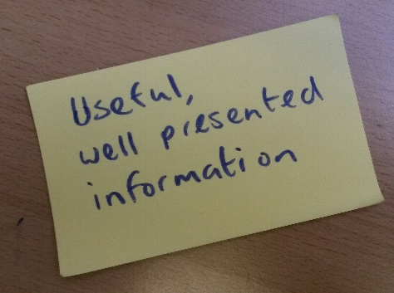
Of the people who filled in feedback forms 89% said that they though the importance and relevance of information in the workshops was ‘very good’ or ‘exceptional’.

Highlights and Quotes from delegates

Highlights
Delegates heard from service users about their experiences. They increased their understanding of how parents might feel about services and what parents find helpful. They also had the opportunity to network with other professional and service-users. Delegates said that highlights for them included “personal stories” and “hearing from people and networking”.

“Listening to service users and watching film was moving and gave a real element that was profound”
Feedback from delegate.

“Informative, interesting and inspirational”

“It was absolutely brilliant!”

“Felt inspired and productive”
Delegates describing the conference.

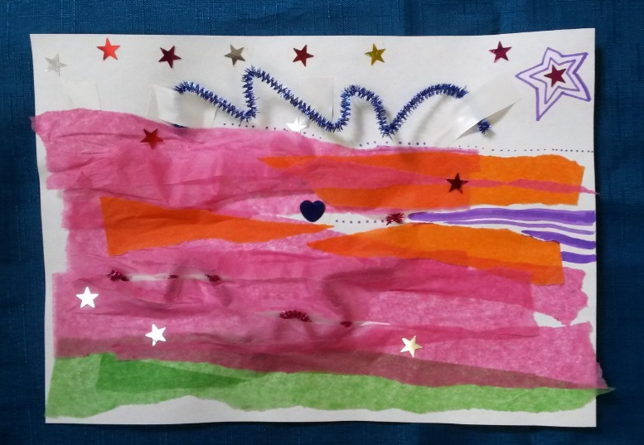

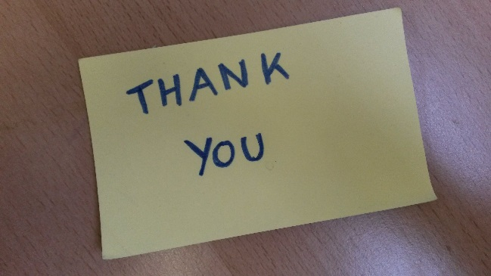
Thank you to everyone who contributed and made Healthy Minds First conference a huGE SUCESS

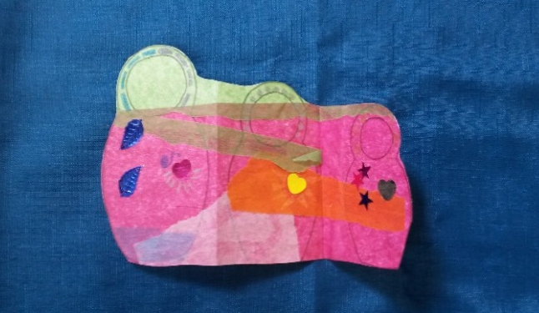

Healthy Minds
To find out more about Healthy Minds Calderdale please see our website http://www.healthymindscalderdale.co.uk/ or ring them on 01422 345154.

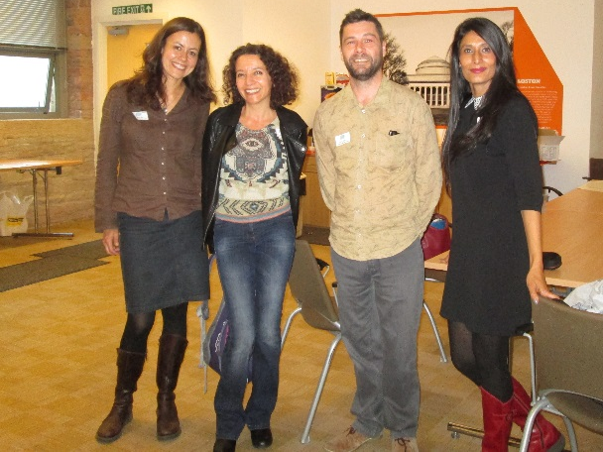
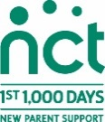
Healthy Minds staff (above)

References: Slay, J. & Stephens, L. (2013). Co-production in mental health: A literature review. London: new economics foundation

