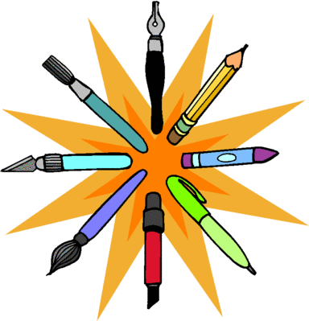
Art and Craft Workshop @ Brighouse Library
2pm-4pm

Healthy Minds are holding a series of art and craft workshops:-
Weaving - Tuesday 19th May 2015
Portrait mosaic - Tuesday 2nd June 2015
Candle decorating - Tuesday 16th June 2015
Tree of life - Tuesday 7th July
You don’t need to have any previous experience or existing skills to participate, just an interest in enhancing your well-being through art and craft activities.
The workshops are free.
If you are interested, then please contact Nicola on 01484 345154 or email on Nicola@healthymindscalderdale.co.uk

The Support Group Project is funded by The Henry Smith Foundation.
Healthy Minds is the operating name for Calderdale Wellbeing
Calderdale Wellbeing Company Number 6828871 Charity Number 1132316

